**National University of Computer & Emerging Sciences, Karachi  
 Spring -2022 CS-Department**Fast

**THEORY PROGRAMMING ASSIGNMENT II**

| **Course Code: CS2006** | **Course Name: Operating Systems** |
| --- | --- |
| **Open Date: 2nd April 2022 Due Date: 10th April 2022** | |

Instruction:

1. This is a programming based assignment
2. Submit it in your GCR.
3. Source code file must be named as **your_roll#.c**
4. Include Readme.docx (not text) containing screenshots of successful running programs and specified compilation criteria if any.

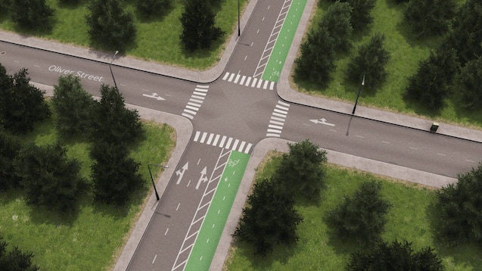

Fast Nuces selects a student to solve teen talwar traffic intersection problem.The details of problem are as follows: in two one-way roads as shown above, traffic is trying to pass through this intersection of roads, such as east to west and north to south without any collision,the intersection road is origin point for cars. Cars have to exit in the opposite direction, therefore cars need to pass through intersections. In this problem, cars are not allowed to take turns. Inside an intersection, more than one vehicle can get in and given that a car's path will not create a collision. Due to some construction problems in this area, a maximum of three cars can get inside the intersection at the same time. Create a program with proper synchronization as per provided scenario.